1. Given the function Z = B’C + A’BD + AB’, fill in the truth-table below.

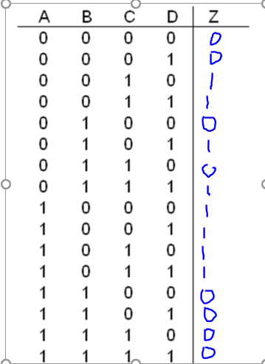

b)  Given the truth table of part (a), implement Z using a single 16:1 multiplexer shown below. Make sure to clearly label all inputs and outputs.

